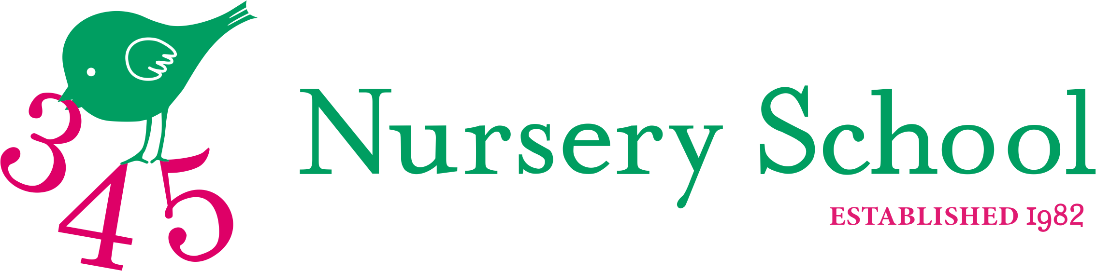
Afternoon School and Lunch Club Summer Term 2022

Afternoon School will start Wednesday 20th April and finish Wednesday 6th July

I would like to reserve a place for _________________________________(child’s name) for the following clubs. Please tick accordingly and return to the office. We have a maximum of 16 places available in each session, which will be allocated on a first come first served basis.

Club and Day | Cost per term £’s | Please tick accordingly
Monday – Ballet until 3.15 pm. Inclusive of lunch club | 340.00
Tuesday - Tennis until 3.15pm. Inclusive of lunch club | 340.00
Wednesday - Football and Ball Games until 3.15pm.  Inclusive of lunch club | 340.00
Thursday – Funky Grooves & Creative Story Telling until 3.15pm. Inclusive of lunch club | 320.00
Friday – Cookery, Science and Nature until 3.15pm.  Inclusive of lunch club | 320.00
Lunch Club Only until 1.30pm Monday | 125.00
Lunch Club Only until 1.30pm Tuesday | 125.00
Lunch Club Only until 1.30pm Wednesday | 125.00
Lunch Club Only until 1.30pm Thursday | 125.00
Lunch Club Only until 1.30pm Friday | 125.00

Total:
Cost of Adhoc session when available: Afternoon Club including lunch club £ 39.50

Parent’s Name:_________________________________ Date:_________________________

Parent’s signature: _____________________________ Total Payment of £ _______________
Please add to my Summer Term 2022 invoice_____. A transfer via BACS has been made______. (please tick accordingly) To pay electronically/ BACS: 345 Nursery School, NatWest Account No 28260368, Sort Code 50-21-01. PLEASE PUT YOUR SURNAME AS REFERENCE AND CONFIRM PAYMENT TO THE SCHOOL OFFICE VIA EMAIL admin@345nurseryschool.com

