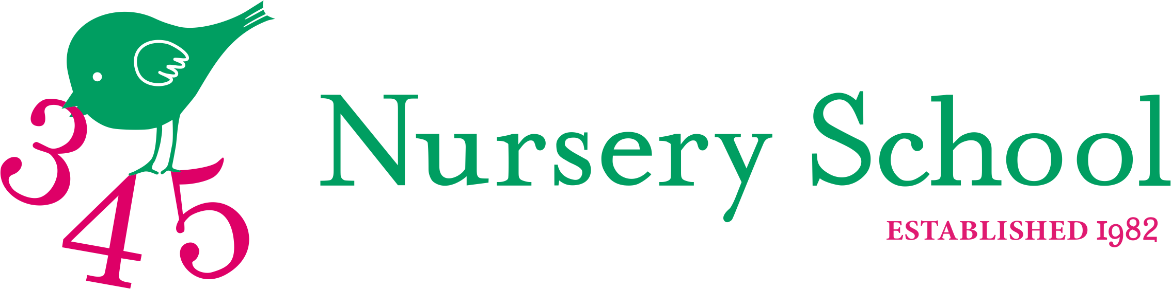
Afternoon School and Lunch Clubs September 2022 – July 2023

Afternoon School will start Wednesday 7th September 2022 and finish Thursday 6th July 2023

I would like to reserve a place for _________________________________(child’s name) for the following clubs. Please tick accordingly and return to the office. We have a maximum of 16 places available in each session, which will be allocated on a first come first served basis.

Places are secured for the following term automatically and fees added to the termly invoice. Should you wish to change any of your bookings for the following term please email Jill so the place can be reallocated to others.

Club and Day | Cost per term £’s | Please tick accordingly
Monday – Ballet until 3.15 pm. Inclusive of lunch club | 350.00
Tuesday - Tennis until 3.15pm. Inclusive of lunch club | 350.00
Wednesday - Football and Ball Games until 3.15pm.  Inclusive of lunch club | 350.00
Thursday – Funky Grooves & Creative Story Telling until 3.15pm. Inclusive of lunch club | 350.00
Friday – Cookery, Science and Nature until 3.15pm.  Inclusive of lunch club | 350.00
Lunch Club Only until 1.30pm Monday | 130.00
Lunch Club Only until 1.30pm Tuesday | 130.00
Lunch Club Only until 1.30pm Wednesday | 130.00
Lunch Club Only until 1.30pm Thursday | 130.00
Lunch Club Only until 1.30pm Friday | 130.00

Total:
Cost of Adhoc session when available: Afternoon Club including lunch club £ 44.00

Parent’s Name:_________________________________ Date:_________________________

Parent’s signature: _____________________________ Total Payment of £ _______________
Please add to my termly invoice_____. A transfer via BACS has been made______. (please tick accordingly) To pay electronically/ BACS: 345 Nursery School, NatWest Account No 28260368, Sort Code 50-21-01. PLEASE PUT YOUR SURNAME AS REFERENCE AND CONFIRM PAYMENT TO THE SCHOOL OFFICE VIA EMAIL admin@345nurseryschool.com

